Central Tendency – HSK Analysis Report
Output Result:
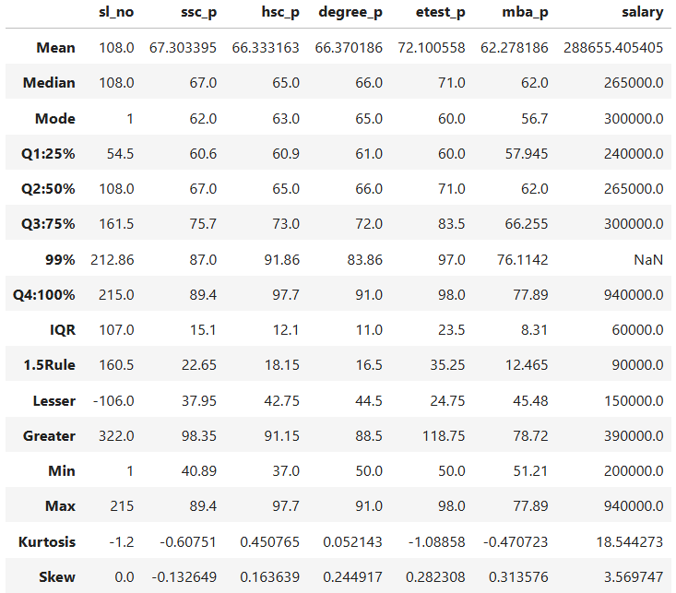
Summary of HSK Analysis

SSLC
- The Kurtosis value of -0.60751 is slightly negative, indicating a platykurtic distribution, meaning the curve is somewhat flatter than a normal distribution.
- The Skewness value of -0.132649 is slightly negative, indicating a minor left skew, with values gently tailing toward the left side.

HSC
- The Kurtosis value of 0.450765 is near to 0, indicating a mesokurtic distribution, meaning the curve has normal peak and tails.
- The Skewness value of 0.163639 is near to 0, indicating a minor right skew, with values gently tailing toward the right side.

Degree
- The Kurtosis value of 0.052143 is near to 0, indicating a mesokurtic distribution, meaning the curve has normal peak and tails.
- The Skewness value of 0.244917 is near to 0, indicating a minor right skew, with values gently tailing toward the right side.

Entrance Test
- The Kurtosis value of -1.08858 is negative, indicating a platykurtic distribution, meaning the curve is flat and spread.
- The Skewness value of 0.282308 is near to 0, indicating a minor right skew, with values gently tailing toward the right side.

MBA
- The Kurtosis value of -0.47072 is slightly negative, indicating a platykurtic distribution, meaning the curve is somewhat flatter than a normal distribution.
- The Skewness value of 0.313576 is near to 0, indicating a minor right skew, with values gently tailing toward the right side.

